**Name: Ali Hassaan Mughal**

**Reg: 173627 CS6B**

**Q1:**

Total numbers of users accommodated for 100% time usage = 8/0.5 = 16;

In case each uses 25% of the time and the probability of providing each with internet is 90%

The users that can be accommodated are 50.

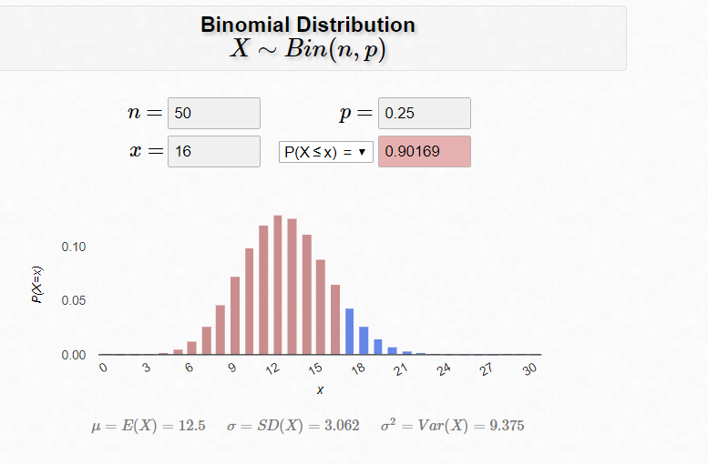

The SMG = 50/16 = 3.125

**Q2:**

A: (L / R) + (m/S)

B: At the t = transmission delay, The last bit is on the link i.e. the transmission medium that will propagate the packet to destination.

C: The first bit is is on the transmission medium it has not yet reached the destination.

D: The first bit has reached the destination on the transmission medium.

**Q3:**

* Please encourage advanced questions in the class.
* It stops my thinking process as when I ask question the question is not answered to lead me to more complex thinking.
* Please keep giving food for thought to those who are asking questions.

**Q4:**

**Analysis:**

As the access networks are deployed on the same route, on analysis it was found that.

The lost packets of Alpha network are 3466 which is greater than (>) the number of packets lost in   
the Bravo network i.e. 949.

The average RTT of Alpha network is 0.0278s which is greater than > the average RTT of Bravo network i.e. 0.0132s.

**Which is Better:**

Bravo Network.

**Reason:**

Since we want the number of packets lost to be least as well as the RTT to be least, hence Bravo network is better as in bravo access network both the number of lost packets and the RTT is also lesser.

**Output**

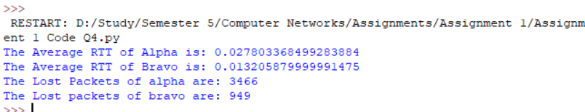

**Code:**

**import csv**

**with open('dataAlpha.csv', 'r') as f:**

**reader = csv.reader(f)**

**alphaList = list(reader)**

**alphaList = alphaList[1:len(alphaList)]**

**with open('dataBravo.csv', 'r') as f:**

**reader = csv.reader(f)**

**bravoList = list(reader)**

**bravoList = bravoList[1:len(bravoList)]**

**lostAlpha = 0; lostBravo = 0;**

**sumAlphaRTT = 0; sumBravoRTT = 0;**

**for alpha in alphaList:**

**if float(alpha[1]) == -1:**

**lostAlpha+=1;**

**else:**

**sumAlphaRTT+=float(alpha[1]);**

**for bravo in bravoList:**

**if float(bravo[1]) == -1:**

**lostBravo+=1;**

**else:**

**sumBravoRTT+=float(alpha[1]);**

**averageAlphaRTT = sumAlphaRTT / (len(alphaList)-lostAlpha)**

**averageBravoRTT = sumBravoRTT / (len(bravoList)-lostBravo)**

**print("The Average RTT of Alpha is: "+str(averageAlphaRTT));**

**print("The Average RTT of Bravo is: "+str(averageBravoRTT));**

**print("The Lost Packets of alpha are: " + str(lostAlpha));**

**print("The Lost packets of bravo are: " + str(lostBravo));**